**User’s guide**

**Smart Calculator**

Perm, 2024

Annotation

This document is a user manual (hereinafter referred to as the Manual) [of the Smart Calculator website](http://grishadzyin.ru.website.yandexcloud.net/).

The user interface of the [site "Smart" calculator](http://grishadzyin.ru.website.yandexcloud.net/) provides information support to the user and convenience of working with square roots.

The guide determines the procedure for working with the site ["Smart Calculator".](http://grishadzyin.ru.website.yandexcloud.net/)

Before using the Smart [Calculator website,](http://grishadzyin.ru.website.yandexcloud.net/) it is recommended that you read this manual carefully.

Contents

Annotation 2

Contents 3

1. Introduction 4

1.1 Application domain 4

1.2 Features at a glance 4

1.3 User Skill Level 4

1.4 List of operational documentation 4

2. Purpose and conditions of use 5

2.1 Purpose 5

2.2 Conditions of Use 5

3. Preparation for work 6

3.1 Procedure for working with the site 6

3.2 Procedure for checking the performance 8

4. Description of operations 9

5. Possible errors and recommendations for elimination 10

1. Introduction
   1. Application domain

The user interface of the site ["Smart Calculator"](http://grishadzyin.ru.website.yandexcloud.net/) provides information support for the user's activities when performing the following operations:

* Square root extraction with specified precision
  1. Features at a glance

The "smart" calculator provides the ability to extract the square root from a certain list of numbers (see paragraph 2.1 Purpose) with an accuracy of 0 to 12 decimal places. If the accuracy is zero, then rounding is carried out according to mathematical rules.

* 1. User Skill Level

Minimum computer skills

* 1. List of operational documentation

1. User’s guide
2. Purpose and conditions of use

2.1 Purpose

The smart calculator is designed to perform square root extraction operations.

The "smart" calculator allows you to perform the following functions:

* Extraction of the square root of a rational number with specified precision;
* Extract the square root of a complex number (entered in the format A + BI) with the specified precision.
* Extract the square root from zero with the specified precision.
* Extract the square root of positive and negative integers (entered without leading zeros, such as "09") with the specified precision.
* Extract the square root of long numbers with the specified precision.

2.2 Conditions of Use

[The "smart" calculator](http://grishadzyin.ru.website.yandexcloud.net/) can be operated and perform the specified functions if the requirements for hardware, system and application software are met.

1. Preparation for work

3.1 Procedure for working with the site

1. Open the site ["Smart" calculator](http://grishadzyin.ru.website.yandexcloud.net/) (Drawing 1).

(http://grishadzyin.ru.website.yandexcloud.net/)

Drawing 1

2. If necessary, change the language in the upper right corner.

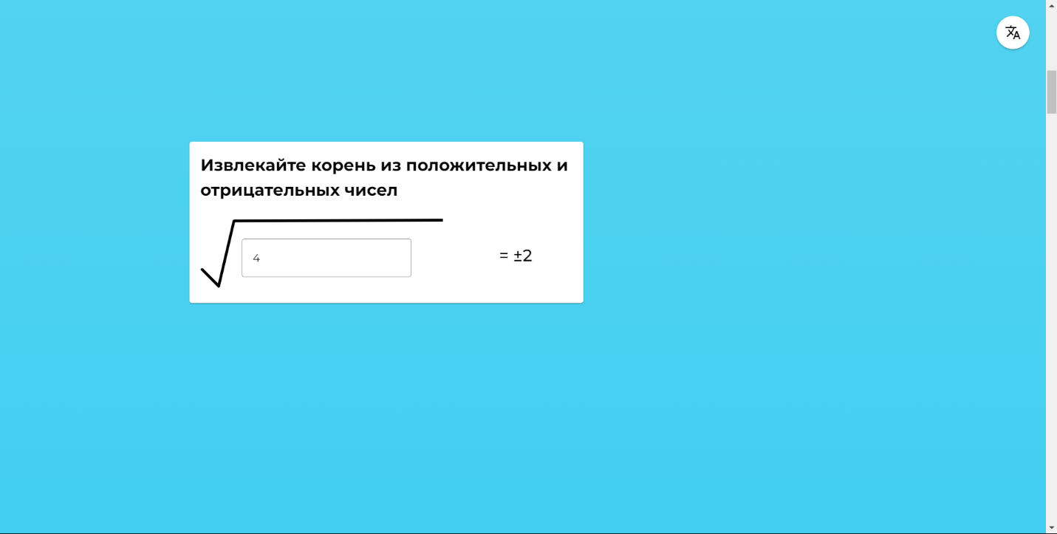3. Scrolling down, you can see the instructions (Drawing 2, Drawing 3, Drawing 4)

Drawing 2

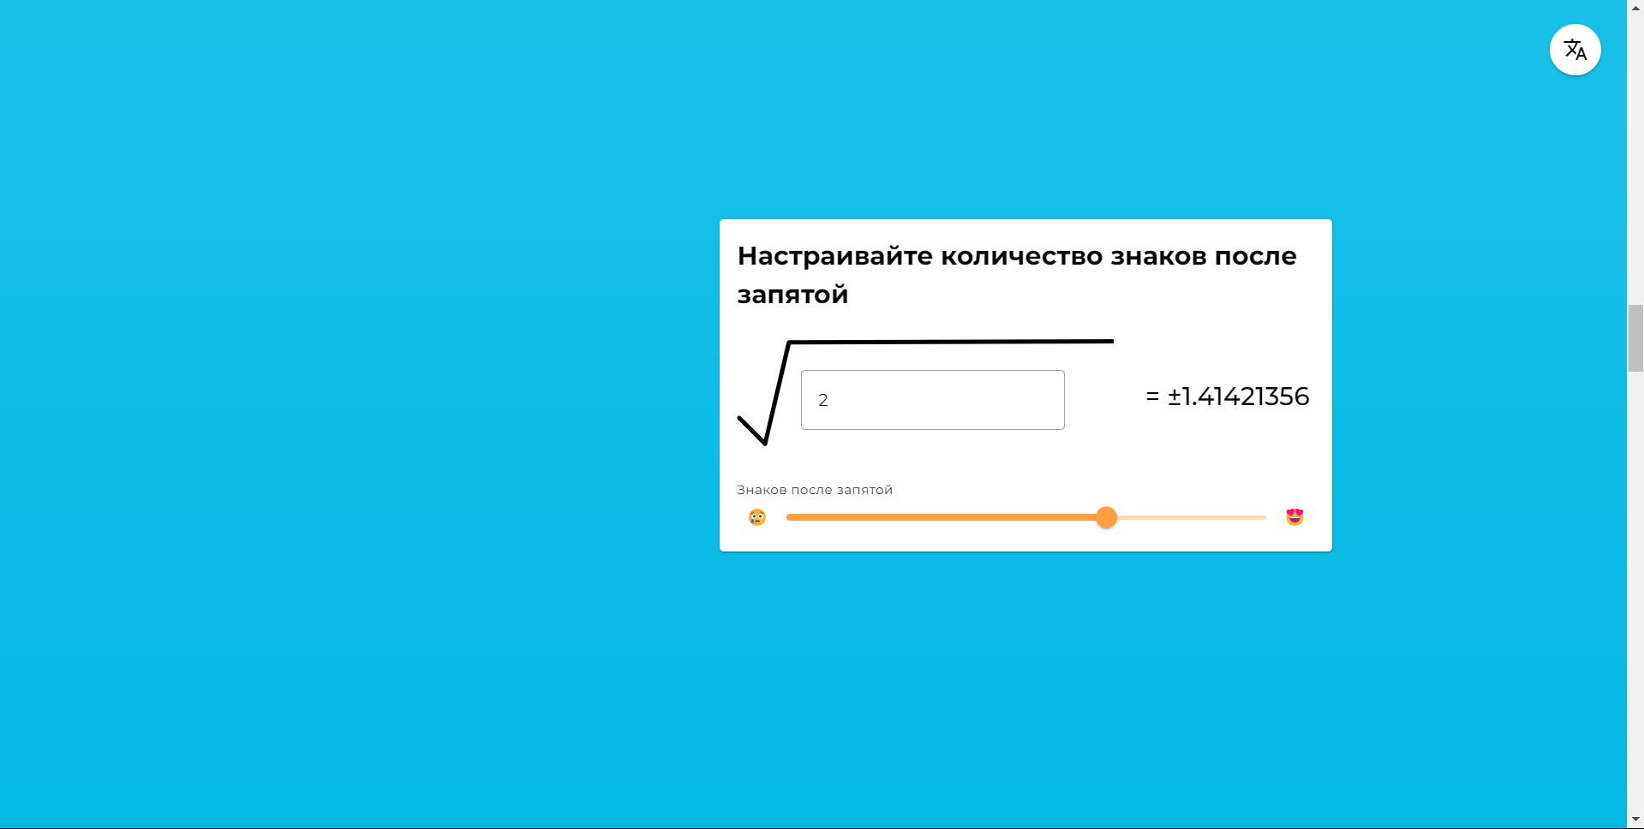

Drawing 3

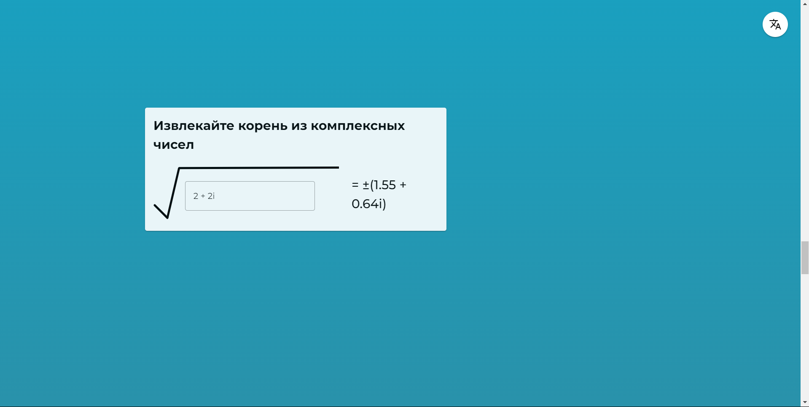

Drawing 4

1. 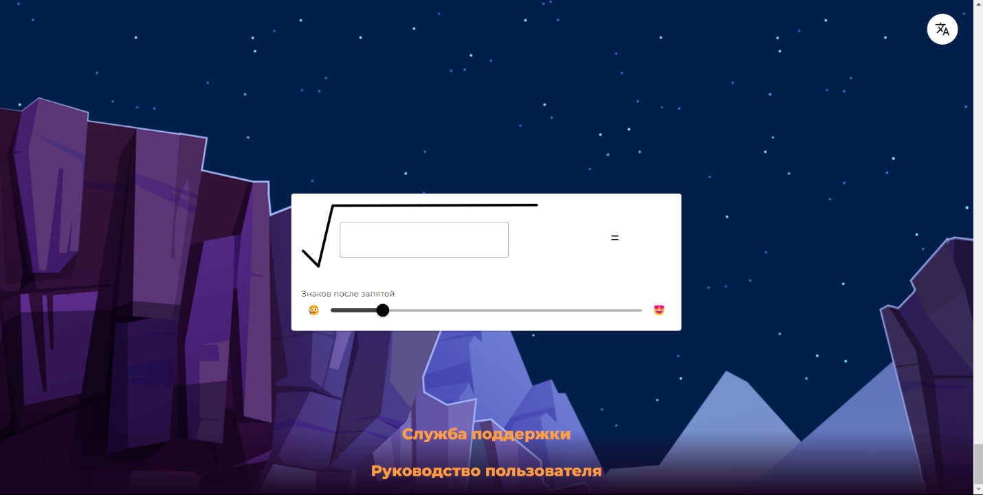At the bottom of the page you can find the calculator itself (Drawing 5).

Drawing 5

1. Also at the bottom of the page is the support service and user manual (Drawing 5).

3.2 Procedure for checking the performance

The Smart Calculator website is checked by performing the operations described in section 4 of this document.

1. Description of operations

This section describes all the operations available on the [Smart Calculator website](http://grishadzyin.ru.website.yandexcloud.net/).

|  |  |  |
| --- | --- | --- |
| **Role** | **Available menu items** | **Available operations** |
| Website user | Visual instruction | Scan |
| Square Root Calculator | Data entryView |
| Support | Clicking on the link |
| User’s guide | Proceed to download the file |

1. Possible errors and recommendations for elimination

|  |  |
| --- | --- |
| Error description | Recommendation for elimination |
| "This is not a number" when entering a complex number | Remove all spaces between numbers and signs, except between the imaginary part of the number and the imaginary unit, remove all characters. |
| "It's not a number" when entering any number | Remove all extra characters except for numbers, "+", "-", i (taking into account the rules for entering a complex number). |